BCM^{lite} Draft user guide

Product Description 4
Overview 4
Operating Modes 4
In-line 4
Dual Subscriber 4
General Features 4
Specific In-line features: 5
Specific Dual Subscriber features: 5
Installation 5
The GTE 5
Overview 5
System Requirements 5
Ordering Options 6
GTE Installation 8
Warning Lights and Labelling 8
Firmware updates 9
Remote Diagnostics 9
Dial Up Connections 9
Configuration Settings 10
Authentication 10
Approved CLI list 10
Graphical User Interface 10
System Requirements 10
Installation 10
Software Updates 10
BCM^{lite} - Principles of Operation 11
Desktop Integration 11
IP Network Address 11
GTE Synchronisation 11
Multiple Control Software Clients 12
Automatic Backup 12
Off-line changes 13
Adding new GUI connections 13
The Configuration Grid 13
Call Plans 14
PBX Failure (In-Line mode) 15
Unassigned Numbers 15
Telephone Number Formats 16
Ranges of numbers 16
Number to re-direct 17
Destination Number 17
Announcements 18
Acceptable Audio formats 18
Recording Audio 18
Drag and Drop 18
Announcement to Caller 19
Whisper Announcement to Agent 19
Order Column 19
Comments 22
Rejecting a call 22
Special Announcement tone 23
Destination Groups 24
Distribution Group 24
Ratio Distribution 24
Rotational Distribution 25
Alphabetic Groups 25
Multiple Groups 26
The Options Pane 27
Timeouts: 28
GTE Status Page 28
GTE Memory Capacity 30
Optional Voicemail / Answerphone 31
Advanced Features 32
Call Throttling 32
Predictive Dialling 33
PRI Selection 33
In-Line Mode 33
Dual Subscriber Mode 34
Announcements Only 34
Data and Video calls 34
Drag and Drop 35
Microsoft Excel 35
IP Network Address 35
Announcements before answer 36
Software version numbers 36
Control Software 36
BCM Explorer shortcuts 37
PC Data Security 37
Synchronisation Failures 38
Upgrades 39
Voice Recording 39
VoiceMail / Answerphone 39
Screen Pop Facility 39
Message Handling 39
GemaTech’s BCM 39
Glossary 40

Product Description

Overview
The BCM – lite is a simple to use powerful, flexible platform. It’s simple management screens are able to accommodate a large number of scenarios.

At its core is the ability to redirect any in-bound call to an alternative location on an individual number basis. It can also distribute calls in any given ratio to a group of recipients, play announcements to callers and the called destination simultaneously.

If a called party is unavailable it’s able to redial alternative locations, play an announcement or optionally record a voicemail message.

A number of pre-defined plans can be pre-configured, modified and activated when required.

Operating Modes

In-line
In this configuration a GTE unit is installed between the Public Network (PSTN) and the PBX.

This allows calls to be redirected either to the PSTN or an alternative PBX DDI. Non re-directed numbers and outgoing calls are passed to or from the PBX seamlessly.

Should the PBX Fail, or need to be taken out of service, individual DDI’s can be redirected to alternative external destinations.

Should the PBX or the PRI to the PBX fail, BCM-lite automatically activates an appropriate pre-configured recovery plan.

Dual Subscriber
This configuration allows the GTE to optionally answer and redirect callers to alternative destinations. This is possible even if only one PRI has been installed or a single PRI fails.

General Features
- Simple user interface with drag and drop support
- Instant plan activation
- Multiple pre-defined plans
- Quick and easy updates to routing plans
- Built-in announcing capability
- Built in whisper / call announce capability
- Build in predictive dialler for increased efficiency
- Re-mapping of any or all individual DDI/DID numbers
- Carrier independent
- Least Cost Call routing and Cost Centre support
- Compatible with both geographic and non-geographic numbers
- Scalable, quick and easy to deploy
- Manages call distribution to multiple sites
- Provides overflow routing to alternative sites
- Support for remote workers
- Built in call throttling for redirected calls
- Optional immediate answering of incoming calls
- Terminate specific DDI/DID’s with Busy, Ringing or Number unobtainable
- Terminate Specific DDI/DID’s with an Announcement
- Supports all call types, Voice, ISDN, FAX, Data, etc..
- CTI Call logging output
- Remote PRI status monitoring
- Optional Secure Voice Recording
  - Secure Remote playback
  - Built-in 10,000 user Answer phone
  - Statistical reporting via ODBC or SQL
  - Web / Java Interface

Specific In-line features:
- Interception of specific DDI/DID’s
- Routing to both internal or external locations
- No additional PRI’s required
- Automatic plan activation if PBX fails
- Handling of unused numbers
- Divert a proportion of calls to another location

Specific Dual Subscriber features:
- External location away from PBX
- Increased redirection capacity (Dual PRI)
- Fall back to a single PRI if one PRI fails

Installation
Installation has two parts, the GTE and the GUI Control Software.

The GTE

Overview
The cornerstone of GemaTech's BCM- lite is GemaTech’s Telecoms Engine (GTE), a state of the art wall or rack-mounting unit, configurable for either single or dual Primary Rate T1, or E1 circuits.

The unit typically occupies no rack space and mounts directly on a wall adjacent to the PRI presentation point.

System Requirements
The unit should mount in a dry location out of direct sunlight and requires no special environmental considerations.

Power must be provided at either 5 Volts DC, or using the PSU provided 80 – 260 VAC. The unit typically consumes 3 Watts of power, and a maximum of 10 Watts.

An RJ-45 UTP Network connection allows user access to the unit to change settings without using ISDN dial-up connections. This method of connection is recommended and essential if Secure Voice Recording (SVR) or Answer phone options are configured.

A Single or Dual PRI is required depending on configuration. If a Single PRI is connected then the unit will operate in Dual-Subscriber mode.

In-Line
Port 1 must connect to the public network, and Port 2 to the PBX.

Dual-Subscriber

If a single PRI is installed it should be connected to Port 1 otherwise both may be connected to the public network.

Part Provisioning

If a trunk has been partially provisioned, there are special considerations and you should contact GemaTech’s customer support – support@GemaTech.com

Ordering Options
The following options must be specified when ordering BCM-lite units. The items in red indicate the standard configuration.

1. | PRI Protocol: | - Euro-ISDN (Q.931/I.421/ISDN30e/)  - DASS(II)  The Protocol must match the settings of the equipment to which the GTE connects
2. | Port configuration: | - In-line  Port 1 connects to the PSTN  Port 2 connects to the PBX  - Dual Subscriber  Port 1 and/or Port 2 connects to the PSTN
3 | Announcements before answer | - Enabled  This will allow announcements to be played to callers without answering the call. This can only be used if supported by the carrier  - Disabled
4. | Combined SVR^{lite} | - Not required  (This is an optional module)  - Required
5. | IP network configuration | - DHCP / DNS based  - Static IP  - IP Address  - Sub-net mask  - Default gateway  Ask you network administrator
6. | Remote Dial-up Access | - Enable  - Permissible CLI’s  - Remote Diagnostics  - Enabled / Disabled
 |  | - Disable
7. | Number of DDI digits | 4 Digits
 |  | This parameter must be no larger than the number of digits passed by the carrier. The number chosen affects the maximum number of DDI’s that can be supported. Eg: 2 DDI digits allows a maximum of 100 separate telephone numbers ending in xxxxxxxx00 to xxxxxxxx99.

GTE Installation
The GTE can be installed within minutes, full instructions are provided within the packaging.

Overriding Factory Configurations
It is possible to override the factory configurations, however extreme caution should be exercised since some settings may remove the ability to make further changes to the configuration. An example would be removing the controlling PC from the Authorised access list for remote ISDN dialup.

Only trained installers should attempt to change the configuration settings for the unit. If you wish to make changes please contact support@GemaTech.com

Warning Lights and Labelling
The unit has the following warning lights:
Power – Green
Port 1 – Amber
Port 2 – Amber
Fault or Bypass – Red
Ethernet Link – Green
100 Mb/s - Amber
Power
This indicator should flash with a 50% Duty cycle during normal operation. If the unit fails it’s power on self test this indicator will not flash and the Fault / Bypass indicator will illuminate.

Port 1 & Port 2
This indicator shows when a valid signal is received on the respective Port. If the indicator flashes then although a valid signal has been received by the GTE, the remote equipment is not receiving the GTE’s signal.

Fault or Bypass Indicator
This will indicate a fault condition within the GTE.

In-Line configuration
When the Bypass Indicator lights or when power is removed Port 1 is electrically connected to Port 2 using an internal relay.

Ethernet Link
This indicates an Ethernet connection has been established correctly

100Mb/s
This indicates that a 100 Mb/s Ethernet connection has been established

Firmware updates
Firmware updates can be installed remotely using a Dial-up ISDN or Ethernet connection. A firmware update will take effect when the unit is power cycled or reset remotely via the Options Panel.

Software update can be downloaded from www.gemanet.co.uk Note that a username and password will be required.

Passwords are issued by Technical Support, please contact support@GemaTech.com

To install an update follow the instructions provided with the update.

Remote Diagnostics
If enabled this option allows GemaTech to remotely diagnose and investigate an issue without the need for a site visit and is highly recommended and a condition of a maintenance contract.

Dial Up Connections
A dial-up ISDN connection can be made if Ethernet connectivity is unavailable. Only one dial-up session using a dial-up connection is supported on each PRI, and requires a dedicated channel on that PRI for the duration of the connection.

With high demand systems where call volumes are expected to be significantly greater than the PRI capacity a dial-up connection is not advised.

Configuration Settings
The configuration settings required are:

Connection type: 64 kb/s ISDN data call
Authentication type: CHAP (not MS-CHAP)

Note CHAP is supported on Windows 2000 or later.

Authentication
The necessary username and password can be provided by support@GemaTech.com

Approved CLI list
Only ISDN data calls from authorised CLI’s will be accepted. These calls can be made to any number terminating on the GTE.

Graphical User Interface
For ease of use the PC client control software provides supports a Graphical User interface. This integrates within Microsoft Explorer (Version 6 or later).

System Requirements
GUI Supported operating systems: | Windows 95 (OSR2)  Windows 98, ME, NT, 2000, XP or Server 3003
PC requirements: | Mouse, Network Interface Card.  Optional:  Sound card, Microphone, Speakers
 | ISDN (II) interface Card

Installation
The Control Software installation uses a Windows Installer program, this contains instructions during the install process.

The user must accept the licence agreement to continue installation of this product. During installation a default location is suggested, this path is assumed to have been used throughout this help.

Software Updates
Control Software updates are available. When installing or updating a newer version of the GUI please uninstall the previous version before proceeding. Since the Control Software forms part of Windows Explorer, you will be required to restart your computer once installation completes.

BCM^{lite} - Principles of Operation
Once the GUI Control Software has been installed it becomes part of the Windows desktop explorer. The Control Software cannot be run from the start bar or by a command line entry.

A special file type is automatically registered with Windows - ‘.gte’ – by double-clicking on this file type launches the BCM^{lite} editor.

Desktop Integration
To create a GTE connection, right-click on the Windows desktop or in a folder and select NEW > GTE
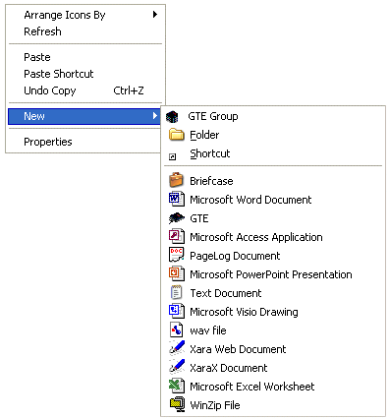

An Icon will be created, it’s name can be modified if required, be sure to maintain the correct filename extension, EG: ‘.gte’.

Note: If the extension is not displayed due to your Windows settings, there is no need to add it.

You can now activate the BCM^{lite} Control Software GUI by double-clicking the GTE icon.

The first time you activate a GTE icon it will ask you to enter the serial number of the unit you wish to connect with, or its IP address.

IP Network Address
Depending on your network’s configuration it may be necessary to enter the GTE’s IP address, please ask your network administrator or the GTE installer for the address to use.

GTE Synchronisation
Once a PC connects to a GTE it will synchronise it’s data. This can take several minutes if it’s the first time this PC has connected with a given GTE.

On subsequent connections only changes in configuration will be sent. This exchange of information is in both directions.

The bandwidth between the GUI and GTE is intentionally limited to avoid network congestion over remote or dial-up links.

Call plans and other configuration information is synchronised in such a way that the most recent changes are kept by both the GTE and Control Software.

The user can synchronise at any time by pressing the ReSync button.

Whilst synchronising a GTE icon appears in the notification tray, (normally near the clock on the windows toolbar). Passing a mouse pointer over the Icon will produce a tool-tip indicating the current state of the transfer.



By double-clicking the Icon a more detailed status is displayed.

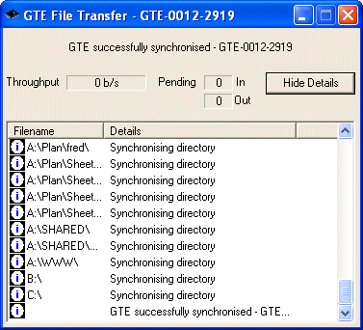

Multiple Control Software Clients
If multiple GUI’s update the same GTE, the most recently changed settings will take effect.

A maximum of 2 clients can connect simultaneously, although changes are not relayed until synchronisation occurs.

Automatic Backup
A backup of all settings within the GTE are automatically made whenever synchronised with the Control Software. This means if a GTE is replaced all settings can be restored to the new unit or replicated for additional units.

Off-line changes
If an IP connection is not available, changes to a call plan may be performed off-line. This is not advised if multiple users control the same GTE since changes may be lost if another user changes settings before synchronisation.

The most recent changes always take priority, not the most recent synchronisation.

Adding new GUI connections
Since the BCM^{lite} function is completely independently, a new client can connect and synchronise to receive configuration settings, Call Plans and Announcements.

This means a fresh installation can connect, activate or modify an existing call plan held on a BCM^{lite}.

The Configuration Grid
Once a successful connection has been established this grid will appear.

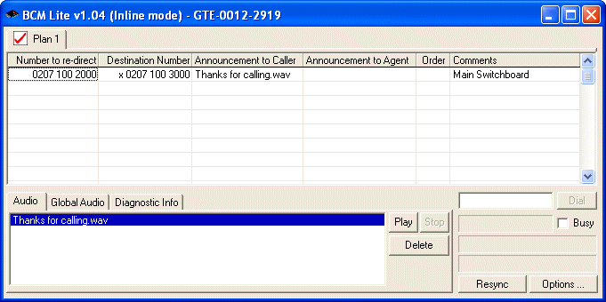

If an error exists in the grid it will be highlighted in red. The reason for the error is displayed by hovering the mouse pointer over the entry.

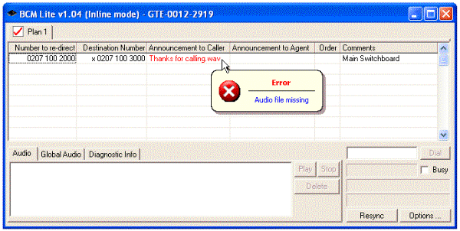
The grid contains a number of columns explained below. The number of rows should not exceed 30,000. If your application requires a larger number of rows please advise support@GemaTech.com for additional advice.

Call Plans
Call plans can be created, deleted or activated using the right-click menu on the plan name tab.

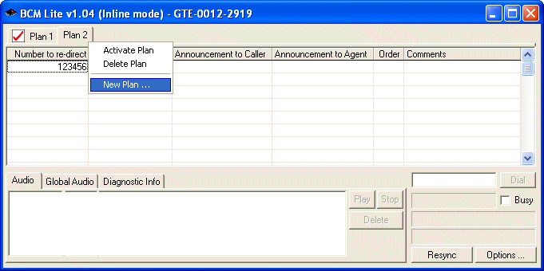

Activating a call plan will automatically trigger a resynchronisation.

Note: The active plan can not be deleted.

It’s possible to activate a Call Plan from the GTE icon by using the right-click menu, “Activate Plan>>Plan Name”. This will open the Control Software GUI and resynchronise the appropriate GTE.

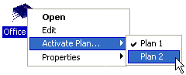
It is recommended that a maximum of 10 plans are used, however more are possible but may result in reduced audio storage capacity. Please contact support@gematech.com for more information.

PBX Failure (In-Line mode)
The Option Panel allows a Call Plan to be activated automatically in the event the PBX or its PRI fails.

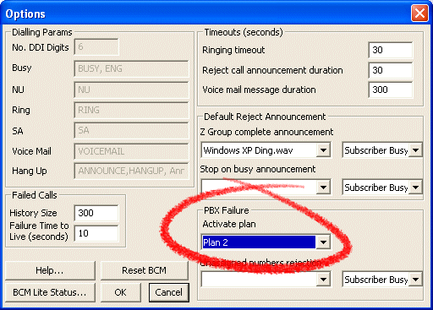

Note the call plan set to activate on PBX failure cannot be deleted.

Unassigned Numbers
Calls to unassigned numbers, not specifically listed in the call plan are managed in accordance with the settings in the options panel.

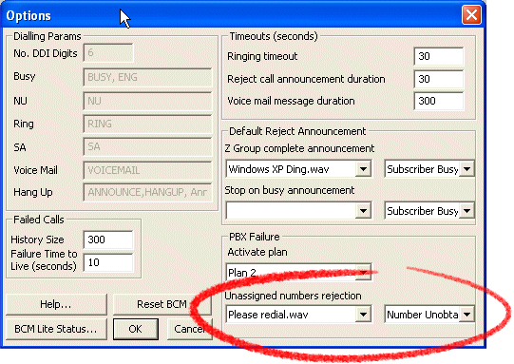

Telephone Number Formats
Any entry in the first two columns contains two parts, text and numeric.

The optional text part has no meaning to the BCM^{lite}, it’s allowed for user convenience. Typically this is used to add meaning to a numeric entry. If present the text part must be first.

The numeric part should include leading zeros. Spaces are allowed within the number to aid readability, but are ignored by the BCM^{lite}.

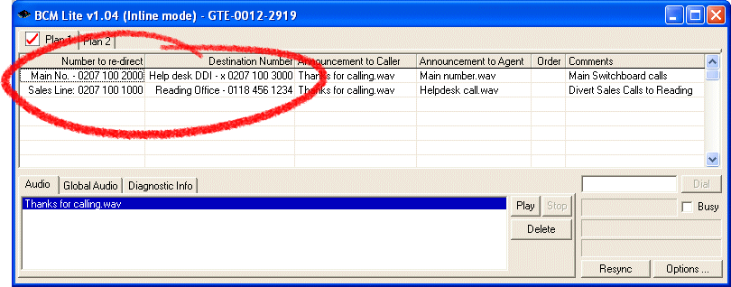

Ranges of numbers
The first column, the number to re-direct, can include a range using a hyphen. This allows blocks of numbers to be treated as a single entry to save repetition.

If the second number has less digits than the first it’s assumed to have the same leading digits.

An asterisk - “*” specifies all numbers not specifically listed in this column. If omitted, BCM^{lite}’s In-Line configuration will automatically pass unspecified numbers to the PBX.

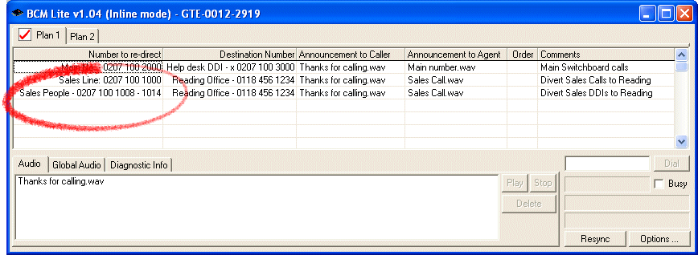

Number to re-direct
This is the DDI or Telephone number to intercept. It can be any incoming number passing through or terminating on the GTE.

Only the last few digits of the number need be included, although it may be easier to manage if the full number is used.

The minimum number of digits required is set at installation time, and can vary between 0 and 29 digits. This number can be found in the options panel.

If insufficient digits are used within a plan the number will appear in red, an additional explanation can be displayed by hovering the mouse over the error.

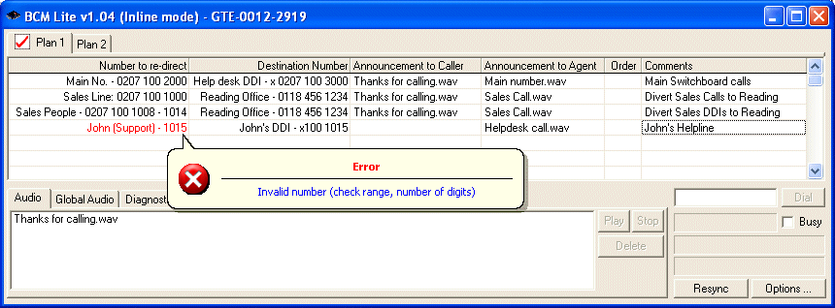

Destination Number
The destination number is the number dialled by the GTE when a match is found in the previous column.

Prefixes such as least cost routing digits and cost centres, withhold and release number can also be included if supported by the Carrier.

For In-Line BCM^{lite}’s, a number prefix of “x” specifies the call out should be dialled on the PRI connected to the PBX. This number should have the same number of digits as the PBX would normally expect. The number of digits expected by the PBX can be obtained from you PBX installer, although in general more digits than necessary or the full number should work fine.

Eg: “Steve’s DDI – x0027” , “Steve’s Home – 01234 123 4567”

Announcements
Announcements can be recorded on any PC and simply dragged and dropped on the BCM^{lite} Control Software. These are automatically transferred to the BCM^{lite} and stored in the GTE’s non-volatile memory upon synchronising.

Announcements required for multiple plans should use the “Global” storage area. This avoids the need to store the same audio multiple times for different plans.

Announcements can also be stored for each call plan; If an individual plans announcement has the same name as a global announcement then the individual announcement will take precedence for that plan.

Up to 10 minutes of audio in total can be stored, however if multiple large plans are stored (thousands of DDI / DID’s and destinations), then this will have an impact upon the amount of audio that can be stored.

See “GTE Memory Capacity”.

Acceptable Audio formats
The audio stored should be recorded in mono CCITT 8 bit commanded A-Law format or ITU-T G.711 format.

In practice the Control Software can convert a multitude of formats, depending on choices made when installing Windows and other audio applications.

Recording Audio
Any Windows audio application can be used to record audio for the GTE. If audio is to be recorded an appropriate sound card, microphone, headphones or speakers will be required.

Drag and Drop
To copy a recording to the Global store simply drag the recording to the Global Audio tab

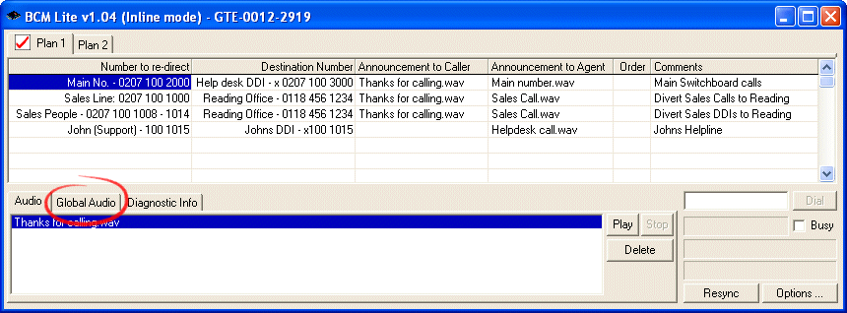

To store audio to a specific Plan’s store, drag the recording’s file to the plan name tag or the Audio tag

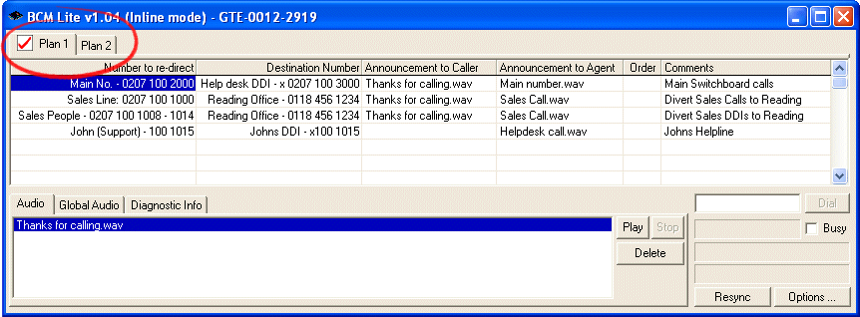

For the highest possible quality, audio files are not compressed on the BCM^{lite}. Synchronising new audio files can take several minutes.

Announcement to Caller
Simply choose or type a name of a recording to play to the caller whilst the destination number is dialled.

Whisper Announcement to Agent
This column may be used to type or choose from the drop down menu the recording to play to the called party once answered.

Order Column
The order column adds great flexibility to call routing. The possible single character entries are:

<blank entry>, <space> or <Asterisk> | Transparent distribution (Without Announcements)  This type of call redirection passes the outcome of dialling the destination number to the caller.  This means the caller hears any messages, tones, ringing sounds or announcements as if they had dialled the number directly.  The call will not be answered until the redirected call has been answered.  If the destination is engaged the caller will hear engaged.  With Announcements:  If an announcement is specified then the call is no longer transparent, the incoming call is answered and once the announcement finishes the destination number is dialled.  The Caller will hear the outcome of the call as if they had dialled the destination number directly after the announcement.  However the call type and the electronic clearing cause will not be transparent since the call has been answered.  Note: The Ring timeout in the options panel has no effect in this mode.
A, B, C, D, E, F, G, H, I, J, K, L, M, N, O, P, Q, R, S, T, U, V, W, X ,Y | An upper case letter of the Alphabet is used to specify a redirected call should be screened, if un-answered for any reason an alternative can be dialled.  With no Announcements:  The incoming call is played an alerting tone. The PSTN network is told the call is proceeding normally.  When the destination has answered the two parties are connected.  With an Announcement to caller:  The call is answered immediately, whilst using a built-in predictive dialler, the GTE dials the destination number while the caller announcement plays. Once answered the parties are connected. The Caller will hear an alerting tone after the Announcement, whilst the dialled number rings.  With a Whisper announcement:  The GTE calculates the expected dialling delay and compensates for any announcement being played to the caller. When the called party answers a whisper announcement is played and the parties connected.  Both Caller and Whisper announcements are played simultaneously. The predictive dialler will dial the destination whilst announcements are in progress.
a, b, c, d, e, f, g, h, i, j, k, l, m, n, o, p, q, r, s, t, u, v, w, x ,y | As with upper case letters – but if any destination number returns Subscriber Busy no alternatives destinations are tried and the call is answered with an optional announcement then disconnected with a preset clearing cause from the options panel, normally busy.
Z or z | As above, however if the destination number is not answered an optional ‘Z’ group announcement is played then the call is disconnected with a preset clearing cause from the options panel.

If an alphabet character is used, parenthesis may be appended to override the length of time a destination should ring before it is considered not answered. The default value can be set in the options panel.

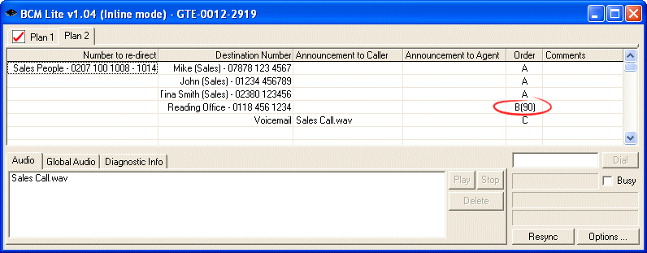

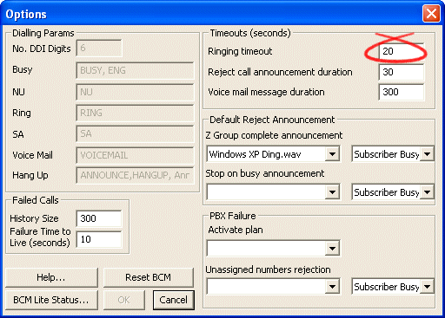

Comments
This column is ignored by the BCM^{lite} and serves a useful location to record miscellaneous information for users.

Rejecting a call
A call may be rejected by placing any of the following Clearing Causes in the Destination number column.

Busy – Clear the call with Busy
NU – Clear with Number unobtainable tone
Hangup – Hang up the call
Ring – Leave the Call Ringing
SA – Clear the call with a Special Announcement Tone
Voicemail – Allow a caller to leave a record a message (See upgrades)

Note that pseudonyms can be specified at installation time, a list can be viewed in the options panel.

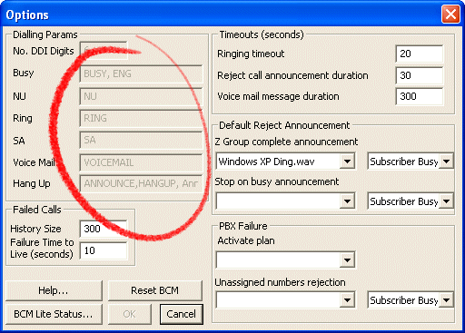

Note that the above clearing causes may play an optional announcement to the caller. If an announcement is played then a channel will remain in use until the call ends.

Note items in Red will use a channel until the incoming call ends even if an announcement is not specified.

Note that ALL clearing causes (except Hangup) will use a channel should the BCM^{lite} attempt to dial a destination number. A channel is not occupied provided the clearing cause is the only item in the destination column for that inbound call.

Special Announcement tone
When ‘SA’ is specified in the destination column, the Special Announcement Tone (Three ascending short tones) are played followed by an optional announcement, referenced in the Announcement to Caller column.

This is repeated until the timeout specified in the Option Panel has been reached or the Caller disconnects.
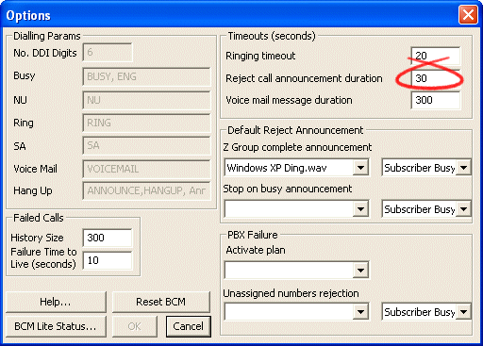

Destination Groups
For each number in the number to re-direct column, multiple destinations can be specified

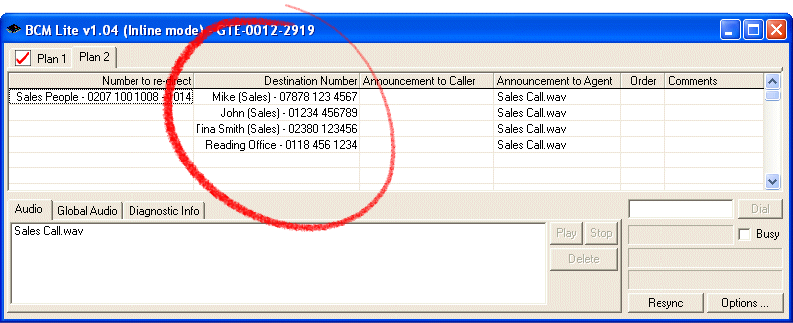

Distribution Group
If there is no alphabetic character present in the order column then this is considered a distribution group. Each time a call is received for this group it’s redirected to the next number within the group

A group ends when a new number to re-direct is found in the first column.

Ratio Distribution
Calls can be distributed in a ratio by simply inserting them within a group more than once.
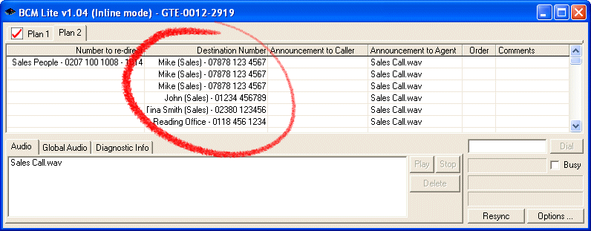

Rotational Distribution
Calls to a distribution group are made in rotational order sometimes called ‘round-robin’. The BCM^{lite} will call the next entry, for the following call.


Note that a new call will start at the next entry within a group, in this example if there were four calls to this distribution group, each would call a different destination, the fifth would call destination 1

Alphabetic Groups
It’s quite normal to have just a single entry within an alphabetic group.

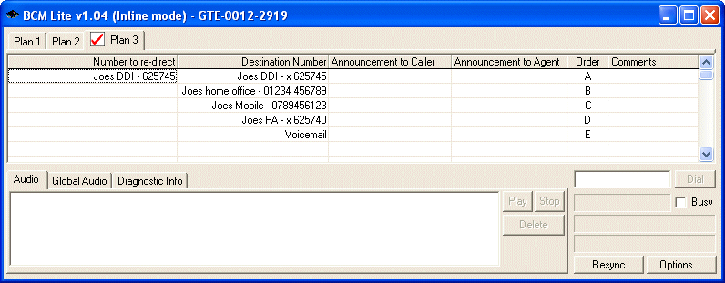

Multiple destinations can be also grouped together with the same order column letter.

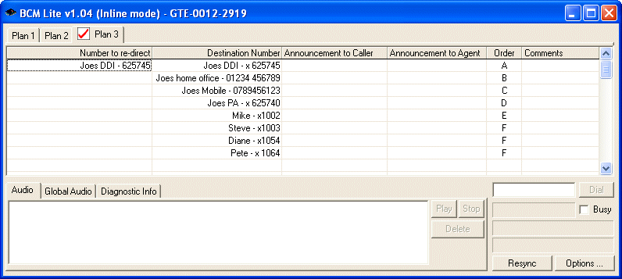

When a Alphabetic letter appears in the order column the GTE will continue to the next entry within the group until the call has been answered.

The position achieved within each group is persistent between incoming calls within the same group. This means that if destination 3 was last called by the GTE, the next incoming call will dial destination 4.

Multiple Groups
It’s possible to have multiple groups signified by different letters of the Alphabet.

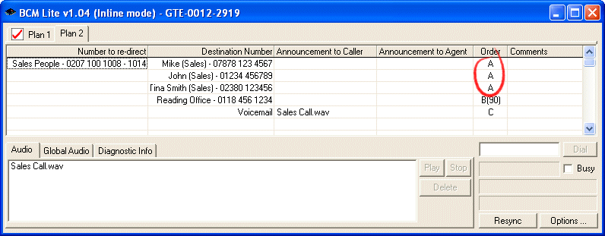

When all the entries within a group have been exhausted the following alphabetically ordered group is selected.

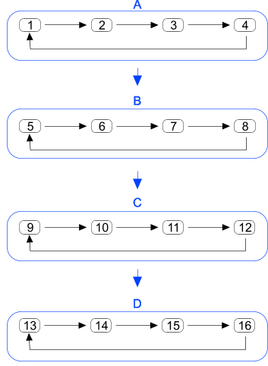

Note groups are independent, when a new group is selected the first call will be the ‘next’ entry within the group, not necessary the first. For example if all destinations within Group’s A and B had been tried, and previously destination 10 had been called last within group C, the first call this time within group C would be destination 11.

The Options Pane
This panel allows default settings to be viewed or in some cases modified.

Timeouts:
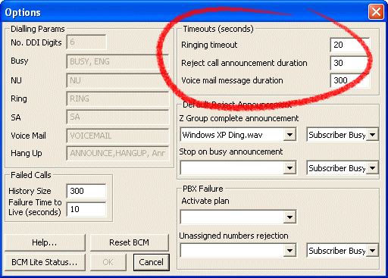

Ring timeout -- the length of time before a call generated by the GTE is considered unanswered.

Reject Call announcement duration – this is the minimum length of time an announcement will play before disconnecting when a call cannot be completed. If an announcement is started it will finish before the call disconnects.

Reject call announcements are, RING, BUSY tones, Number Unobtainable and Special Announcement Tones with an optional announcement.

GTE Status Page
A status page shows the current state of the BCM^{lite}. This can be displayed via the options panel.

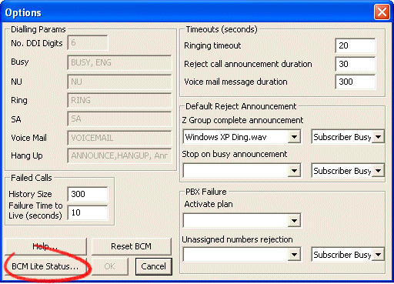

This will activate your browser and display the status page as shown below.

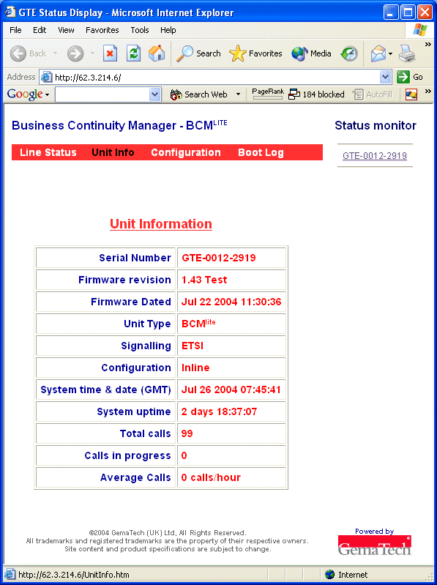

Use the menu bar to select the information required.
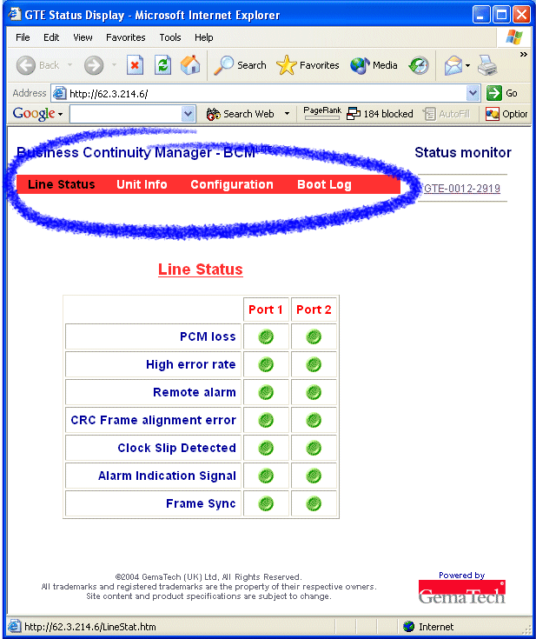

GTE Memory Capacity
The GTE has the ability to hold approximately 10 minutes of audio. For maximum flexibility the store is not divided up in to sections.

This allows the user the option to use the entire capacity for Global Audio, or audio for an individual plan, a very large call plan or multiple plans – or any combination in between.

The following table provides a rough guide to the equivalent storage time a plan will occupy in the store. This must be multiplied by the number of Plans required.

No. of DDI to re-direct | Approximate announcement equivalent
100 | 1 Second
1000 | 4 Seconds
10000 | 45 Seconds

When re-synchronising, consideration should be made that until the settings have been received, both the old and new settings will use the same storage area. Should calls in progress require an announcement or other resources from an old call plan, these will not be freed until the call completes.

Furthermore, a record is maintained within the GTE of deleted items, enabling other PC’s to be synchronised correctly, this also utilises the main storage area on the GTE.

For all these reasons it is always prudent not to press the boundaries of the theoretical storage maximum.

Optional Voicemail / Answerphone
To provide voice mail to any incoming number simply inserts ‘Voicemail’ as a destination number. An optional announcement can also be placed in the announcement to caller column.

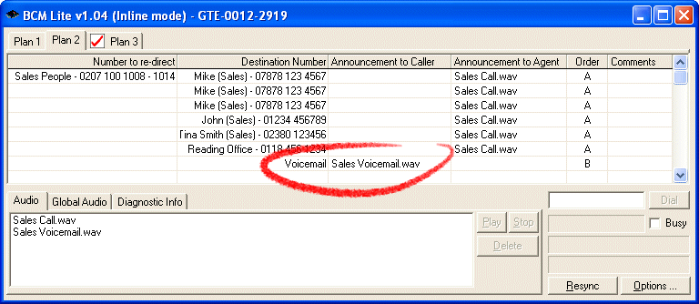

Pseudonyms for ‘Voicemail’ can be found in the options panel.

Note that announcements for voicemail count towards the total announcement storage space, however recordings left by callers do not.

The maximum duration of a callers recording is also set in the Options Panel.

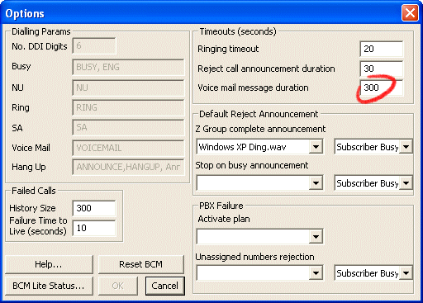

Advanced Features

Call Throttling
In the event a redirected call fails to connect, that destination is flagged as temporary unavailable. This stops an avalanche of repeat call attempts when the network is congested or a destination is overwhelmed.

The period the destination is disabled can be configured or disabled altogether within the Options Panel.

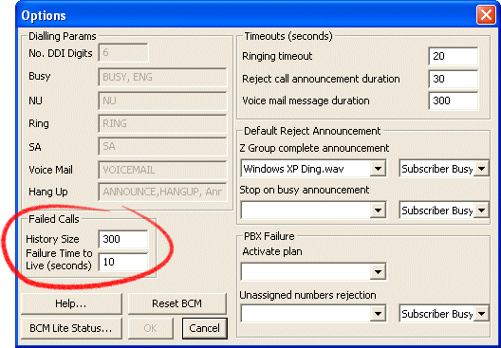

The History Size is the number of failed dialling destinations remembered by the GTE suitable values are between 1 and 300 (0 = disabled)

The Failure Time to Live is the duration before a previously failed call will be tried. Suitable values vary between 1 and 600 (0 = disabled)

This feature allows calls to congested numbers to be handled quickly, freeing capacity to handle other calls. However use of this facility should be carefully considered and may not be appropriate for all applications.

Predictive Dialling
The BCM^{lite} records the length of time taken to dial, route and receive an alerting signal for each destination dialled. It maintains a weighted moving average of this delay and pre-empts this delay by dialling the destination at the correct point within an outgoing announcement to ensure speedy connections, especially to mobile and international numbers. Reducing connection latency and increasing call volumes.

PRI Selection
When a call is re-directed the outgoing PRI is dependent on the operating mode of the BCM^{lite}.

In-Line Mode
Selection of the outgoing PRI is in accordance with this table.

Incoming PRI | Destination | Outgoing PRI
Port 1 | Announcement / Voicemail | Not required
Port 1 | PSTN number | Port 1
Port 1 | PBX number (‘x’ prefix) | Port 2
Port 2 | Transparent – PBX outbound call | Port 1
Port 1 PRI Failure | Notification passed to PBX | Port 2 – Emulate fault condition

Dual Subscriber Mode
Incoming PRI | Destination | Outgoing PRI
Port 1 | Announcement / Voicemail | Not required
Port 2 | Announcement / Voicemail | Not required
Port 1 | PSTN number | Port 2
Port 2 | PSTN number | Port 1
Port 1 (Port 2 PRI Failure) | PSTN number | Port 1
Port 2 (Port 1 PRI Failure) | PSTN number | Port 2

Announcements Only
The BCM^{lite} can be used to play just announcements or with the optional Voicemail module, take messages. Since no outgoing channels are required this allows up to 60 calls to be handled at once by the Dual Subscriber BCM^{lite}.

This may be useful as an initial response in high volume applications.

Data and Video calls
The GTE will transparently switch all call types, however announcements are automatically suppressed for non-audio call types.

Drag and Drop

Microsoft Excel
If large replicating plans with consecutive number sequences are required it may be more appropriate to design your Call Plan with Microsoft Excel. Once saved the Excel file can be dragged and dropped on the to BCM^{lite} Control Software for import.

The Sheet names are automatically used as the plan name, and any number of sheets (Plans) can be included within the same Excel workbook.

The first row may contain column titles for ease of use.

Special consideration should be given when importing telephone numbers. Care must be taken to include leading zero’s. This can be achieved by setting the format of the first few columns to ‘text’.

When importing multiple sheets the user can select which sheets to import.

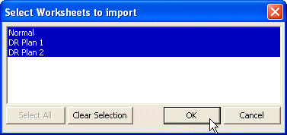

Announcement names, the order and comments columns can also be included

The Diagnostic Info tab can be used to identify problems on import.

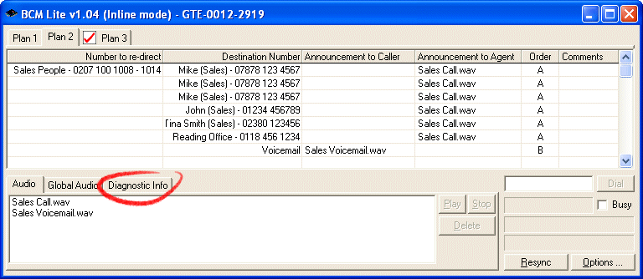

IP Network Address

If your data network policy allows your DNS to be updated by the GTE unit, (or your DHCP server registers the GTE with your DNS) only the serial number will be required.

If there is no DNS record of the GTE then an IP address will be required, please ask your network administrator or the GTE installer for the IP address to use.

Announcements before answer
If configured upon installation, this facility allows announcements to be played to the caller without answering the call.

This facility is sometimes calls ‘Backward Announcement Path’ and must also be configured by the Carrier (who may charge for such a facility).

This allows callers not to pay until the call is answered by the re-directed party.

Software version numbers

Control Software
The version of the Control software together with it’s operating mode is displayed on the windows title bar.

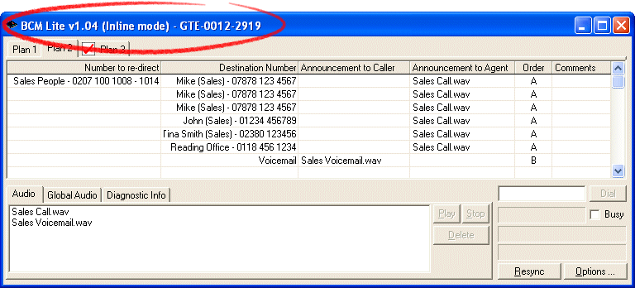

GTE Firmware revision number can be found via the Control Panel and Status page Menu.

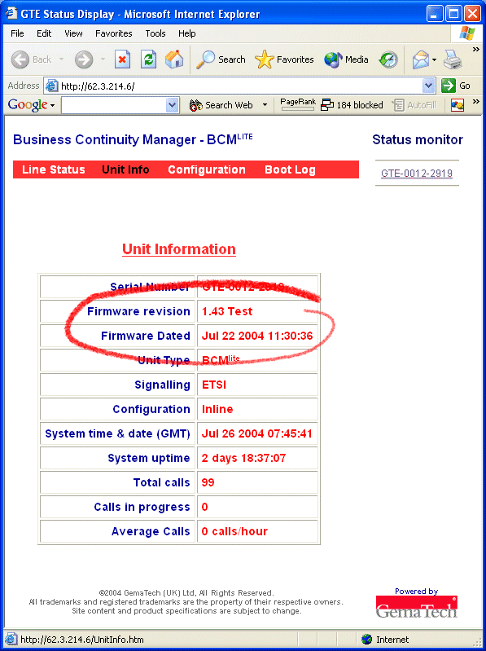

BCM Explorer shortcuts
The Icon created using the Right-Click, New GTE option is only a shortcut to the GTE. No data, plans or recordings are stored within this file. It can be copied and passed to another computer, providing the Control Software has been installed.

If a shortcut is deleted no information is lost and can easily recreated, resynchronisation is not required.

PC Data Security
The PC on which the controlling software’s operated keeps a copy of each GTE’s settings to reduce synchronisation time.

This copy can be found at %Program Files%\GemaTech\BCM lite\GTE. Each separate GTE will have a folder named after the unit’s serial number.

These settings are not scrambled, if the BCM^{lite} contains sensitive information it’s recommended that an appropriate PC filling system is used that allows user privileges to be assigned to these folders.

Only suitably qualified technicians should modify any files contained within these folders

Synchronisation Failures
A synchronisation failure can occur for many reasons. The BCM^{lite} Control Software will automatically re-try if a failure occurs. If the control software fails to synchronise with the GTE a cross will appear on the transfer Icon in the notification area, normally near the time.



Hovering over the notification Icon shows the current status of the synchronisation.
Double-Clicking the Icon will display more detail during the transfer operation.

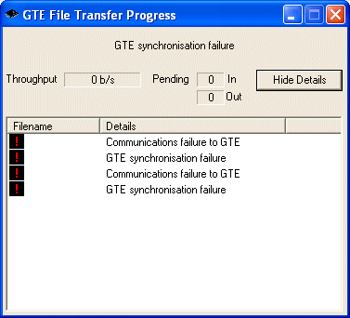

Possible failures are:
Ethernet connection failure
Router Failure
Dial-up connection lost
TCP error
TCP timeouts
Exceeded the maximum number of Control Software clients
The GTE’s Storage capacity has been exceeded.

If you experience unexplained problems please contact support@GemaTech.com

Upgrades
The BCM^{lite} has the ability to be updated remotely with additional facilities. Additional modules allow features to be provided at a later date. These include:

Voice Recording
This module provides audio recordings of all telephone traffic passing through the unit. More details can be obtained from sales@gematech.com

VoiceMail / Answerphone
This module provides 10,000 voice mailboxes to be configured within call plans. Every unanswered DDI has it’s own mailbox. Callers can be directed directly to voicemail if required.

Voice messages are exported to a NAS device for later retrieval. Typical storage devices allow thousands of hours of messages to be stored.

Playback is via a standard web browser, with an optional notification Icon on the Windows toolbar.

Screen Pop Facility
The BCM^{lite} can also provide a screen popping facility based on the number dialled by the caller. This screen pop can trigger PC or web applications even for remote users.

Message Handling
A message taking facility allows a callers message to be recorded and posted electronically to a recipient via email or a web page removing the need for paper based systems.

Multiple recipients are supported.

GemaTech’s BCM
The BCM^{lite} is based on GemaTech’s BCM.

The BCM handles calls differently to the lite product and intended to provide Call Centre facilities either locally or in a distributed manner.

The BCM’s main features are:

- Routing of calls can be based upon one or more of the following:
  - Skills required
  - Service required
  - Agents availability
  - Callers CLI
- Agents may log on and off at will
- Allows rosters on a per agent basis
  - Agents can be assigned work periods on a calendar
- Live Status Monitoring
  - With optional live voice monitoring (Mouse Over Monitoring)
- Statistics
  - Comprehensive Statistics
- Screen Pop and Call notifications on the Windows Toolbar
- Secure Voice Recording (SVR)

Glossary

GTE | GemaTech Telecoms Engine, a dual PRI, compact telephony switching & IVR platform with integrated IP support.
BCM | Business Continuity Manager - A range of products designed by GemaTech to maintain and Manage Business telephony services during a crisis.
SVR | Secure Voice Recorder – This is an optional recording software module that can be installed on the GTE platform. It supports full duplex high quality recording of all calls passing through the GTE.
PRI | Primary Rate Interface – This is typically called an E1 in Europe or T1 in America. It contains either 30 (E1), 23 or 24 (T1) channels. Each channel supports 64kb/s of data or an uncompressed audio call.
IP | Internet Protocol – This is a mechanism that allows different systems to communicate with each other.
DNS | Domain Name Service – This service allows a computer to look up the address (IP address) related to a user friendly name (Eg: google.com)
DHCP | Dynamic Host Configuration Protocol – This facility allows computers to be given an IP address. The computer will submit it’s name and the DHCP server will allocate an address and a period of time it may use this address.
Protocol | This is the method of communicating information between equipment. Each piece of equipment must understand the same protocol for the information exchange to be successful.
Dual Subscriber | A Dual Subscriber interface is two PRI connections to the same GTE
In-Line | An In-line configuration is when the PSTN connects to Port 1 on the GTE, with Port 2 connected to the PBX.
Static IP | A Static IP address is where an IP address is predefined and not allocated by a DHCP server
Subnet Mask | A Subnet mask allows a computer to know if other equipment with similar addresses is nearby or if a Default Gateway should be used.
Default Gateway | A Default Gateway is a portal from one computer network to another.
CLI | Calling (or Called) line Identity – This is normally the telephone number of the party making the call. Sometimes the CLI is partially or completely withheld.
Firmware | The non-volatile software on a programmable computer. Firmware is normally not stored on moving parts like disk drives
GUI | Graphical User Interface – this provides an interface using a graphical display and does not require knowledge of programming scripts or languages.
DDI | Direct Dial In – the number dialled by the caller to reach a specific service or extension. Normally a range of DDI numbers are provided on a PRI.
DID | Direct Inward Dial – the number dialled by the caller to reach a specific service or extension. Normally a range of DID numbers are provided on a PRI, normally in the context of bypassing a receptionist or switchboard operator
ODBC | Short for Open DataBase Connectivity, a standard database access method developed by Microsoft Corporation. The goal of ODBC is to make it possible to access any data from any application, regardless of which database management system is handling the data.
SQL | SQL is an ANSI standard computer language for accessing and manipulating databases, variations are used in almost every database management system available.
PSU | Power Supply Unit – A PSU is used to convert mains utility voltage to a safe low voltage.
UTP | Unshielded Twisted Pair – This is the wiring type normally used to link Ethernet connections between computers over local area networks (LAN’s).
RJ-45 | An eight-wire connector used commonly to connect computers onto local area networks (LAN’s), especially Ethernet. RJ-45 connectors look similar to the ubiquitous RJ-11 connectors used for connecting telephone equipment, but they are somewhat wider.
ISDN | Integrated Services Digital Network, is a system of digital phone connections. This system allows voice and data to be transmitted simultaneously across the world using end-to-end digital connectivity.
Part Provisioning | When ordering a PRI trunk, it is possible to request a proportion of its full capacity, reducing setup and recurring costs. Most carriers will allow as few as 6 channels to be provisioned.
PBX | Private Branch Exchange (Similar to a PABX) this is a telephone switching platform able to direct incoming calls to an extension or service.
Public Network | The Public Network is a network of communication systems allowing users to communicate with others.
PSTN | Public Switched Telephone Network is a network of communication systems allowing users to communicate using non-dedicated circuits with others. Typically by dialling a telephone number.
Microsoft Explorer | A program provided when Microsoft Windows is installed. This program is used as a user interface enabling programs to be started and the content of folders to be viewed
NAS | Network Attached Storage – This is storage devices that connect to local area networks (LAN’s). These network storage devices allow network users to store their files on these devices
Agent | Used in the context of a contact centre or call centre, it is the person answering the telephone.
Alerting Tone | This is a telephony term signifying that the called parties phone is ringing. This is both an audible sound and an inaudible electronic signal sent to the caller’s equipment indicating the phone is ringing.
Call Type | Telephone calls on PRI’s have a call type. This type allows the terminating equipment to handle the call correctly. In this way a normal telephone call can be differentiated to a video conference call.
Clearing Cause | When a telephone call ends an electronic signal is sent to the callers equipment with the reason for the end of a call. This reason allows the equipment to display information or play a message to the caller. Such messages can be, “No Answer”, “Busy”, “Sorry there is a Fault” etc.
Whisper | In a contact or call centre context this is a facility normally only found on high end PBX’s allowing a message or announcement to the Agent informing them of the source or type of call they are about to answer. The calling party cannot hear this announcement.
Predictive Dialler | A Predictive Dialler is a module able to predict when a call will be connected. By dialling before the Agent is ready such that the call will be connected at the same time the agent is ready is Predictive Dialling.
Channel | A unit used to divide capacity of a PRI
Distribution Group | A distribution Group is the ability to distribute calls in a fair manner to multiple destinations.
Rotational Distribution | Is the distribution of calls based on the longest waiting destination within a group. This is sometime called ‘Round Robin’ distribution.
Persistent | The ability to retain information or settings when power is removed or the telephone call terminates
Carrier | The PSTN operator that is connected to the GTE

